**Nguyễn Đình Việt Hoàng – 522H0120 Huỳnh Vũ Minh Hiếu– 522H0024  
Hoàng Văn Minh - 522H0020  
Ngô Trung Tiến – 522H0040**

**ASSIGNMENT REPORT REQUIREMENTS ANALYSIC AND DESIGN**

**HO CHI MINH CITY, YEAR 2024**

**Nguyễn Đình Việt Hoàng – 522H0120 Huỳnh Vũ Minh Hiếu– 522H0024  
Hoàng Văn Minh - 522H0020  
Ngô Trung Tiến – 522H0040**

**ASSIGNMENT REPORT REQUIREMENTS ANALYSIC AND DESIGN**

**HO CHI MINH CITY, YEAR 2024**

**ACKNOWLEDGEMENT**

We sincerely thank Teacher Hồ Thị Thanh Tuyến for teaching us the Requirements Analysic and Design course with great enthusiasm. We want to express our deep appreciation for the dedication and professional knowledge that you shared with us. Through your classes, we gained a better understanding of the fundamental aspects of the Requirements Analysic and Design, thanks to your detailed explanations and practical applications. You helped us grasp the knowledge and apply it effectively. Finally, we extend our heartfelt gratitude to Teacher Hồ Thị Thanh Tuyến for your commitment and invaluable support throughout our learning journey in this course. The skills and knowledge we acquired will continue to impact our future development. We sincerely thank you and wish you health, success, and happiness.

*Ho Chi Minh City, April 11, 2024 Authors*

*(sign and write your full name) Nguyễn Đình Việt Hoàng*

*Huỳnh Vũ Minh Hiếu*

*Hoàng Văn Minh*

*Ngô Trung Tiến*

# THE COMPLETION REPORT HAS BEEN SUBMITTED AT TON DUC THANG UNIVERSITY

Our group assures that this is our own report and was guided by Teacher Hồ Thị Thanh Tuyến. The research content and results in this report are honest and have not been published in any form before. The figures in the tables used for analysis, comments, and evaluations were collected by the authors from various sources clearly stated in the reference section.

Additionally, the report includes some comments, evaluations, and data from other authors and organizations, all of which are cited and noted for their origin.

**If any fraud is detected, we fully take responsibility for the content of our midterm report for the second semester of the 2023-2024 academic year.** Ton Duc Thang University is not involved in any copyright or intellectual property violations that we may cause during the process (if any).

*Ho Chi Minh City, April 11, 2024 Authors*

*(sign and write your full name) Nguyễn Đình Việt Hoàng*

*Huỳnh Vũ Minh Hiếu*

*Hoàng Văn Minh*

*Ngô Trung Tiến*

Supervisor’s Name: ……………………………………………………………..............

Comments: ……………………………………………………………………………...

Total Score Based on Rubric Evaluation: ……………………………………………….

*Ho Chi Minh City, date … month … year … Supervisor*

*(sign and write your full name)*

TOPIC - 8

DIAGRAM CATALOG

Task 1: Use case diagram 9

Task 2: Activity Diagram. 13

Task 3: Class Diagram. 23

Task 4: Sequence Diagram 24

Task 5: Database Model. 30

## TOPIC: My Restaurant Management Project

My Restaurant is a restaurant chain that has just entered the Vietnamese market. It is expected that the restaurant chain will open for service later this year. They have a need to manage a chain of restaurants using information system. Requirements are collected and arranged in order of priority from top to bottom:

**1. Ordering Section at the Table:**

* Display dishes available for the day with prices on a touch screen.
* Diners can select dishes and quantities via the touch screen, reducing the need for wait staff.
* Notifications alert diners when their food is ready for pick up at the service counter.
* View current bill, including ordered dishes, prepared dishes, total amount, and bonus points.
* Payment is made at the cashier.
* Bonus points can be earned by scanning a card at the table's card reader.

**2. Chef's Section:**

* Chefs can manage the list of dishes available each day.
* When an order is placed, the chef receives information on the dish and quantity.
* Confirmation is given when dishes are prepared.

**3. Cashier Section:**

* Cashiers announce and calculate bills based on table numbers.
* End-of-day procedures include printing total sales and dish lists.

**4. Guest Section:**

* Website provides information on daily offerings at all branches.
* Touch screen modules are available at dining tables.

**Non-Functional Requirements:**

* The system prioritizes user-friendliness.

**Task 1/ Use case diagram**

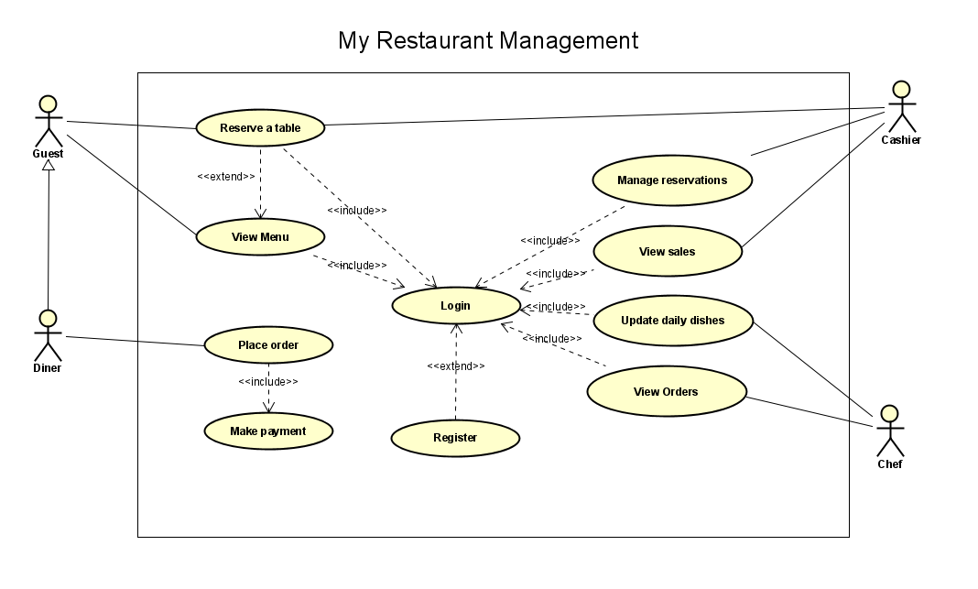

**1.1 Login**

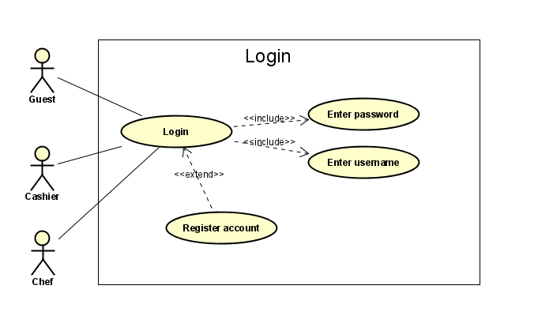

**1.2 Register**

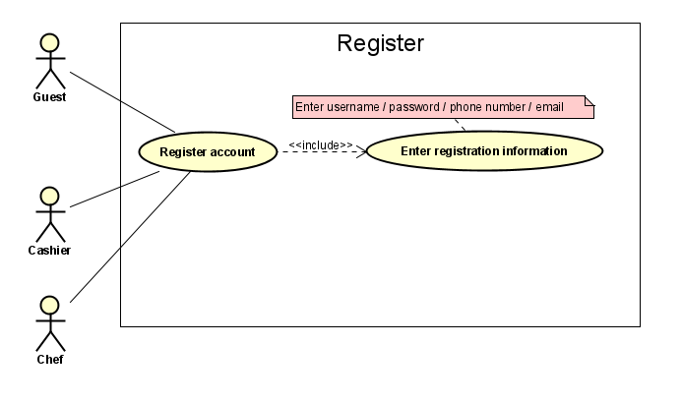

**1.3 View menu**

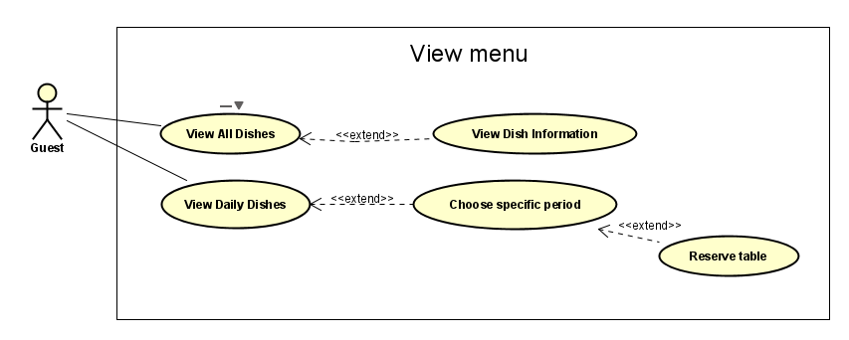

**1.4 Reserve Table**

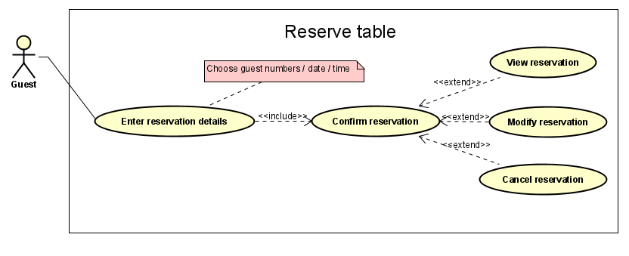

**1.5 Place order**

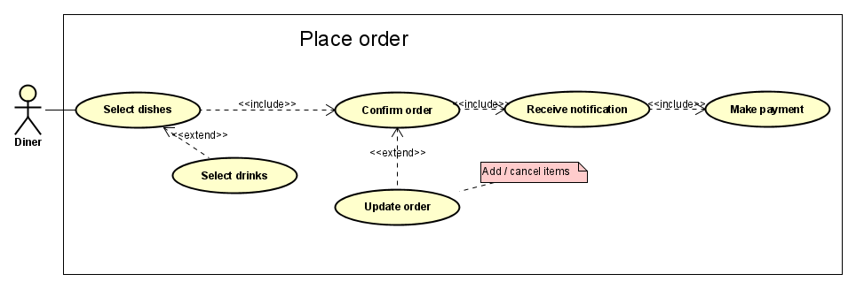

**1.6 Make Payment**

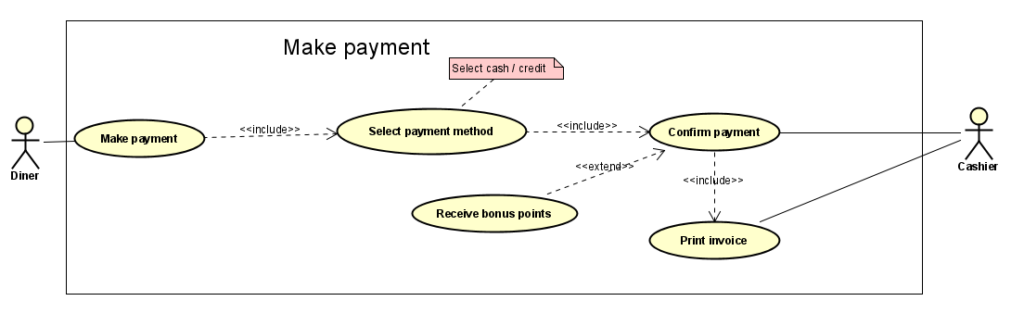

**1.7 Manage daily dishes**

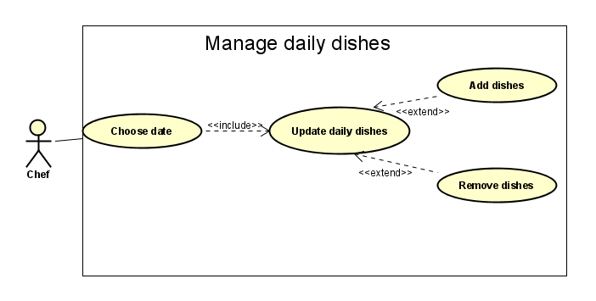

**1.8 View orders**

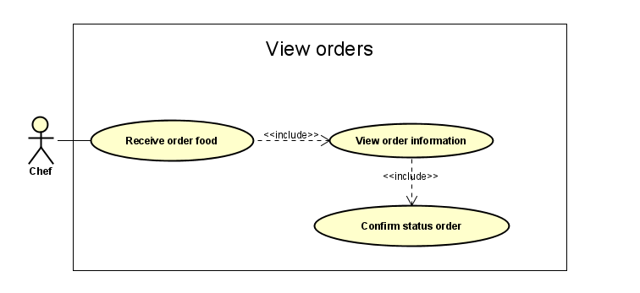

**1.9 Manage reservations**

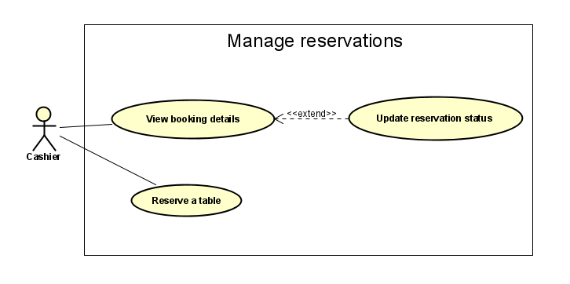

**1.10 View sales**

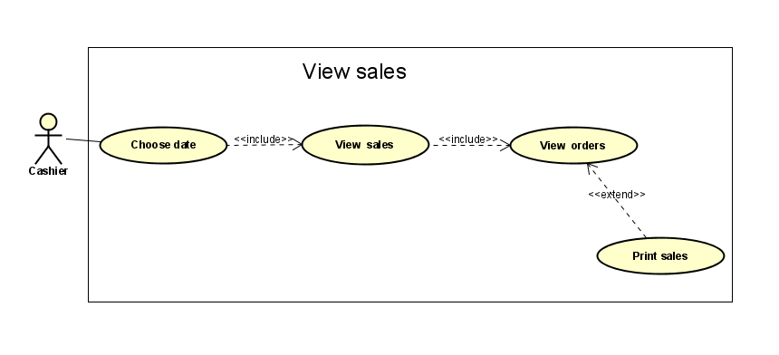

**Task 2/ Activity diagram**

**2.1 Login**

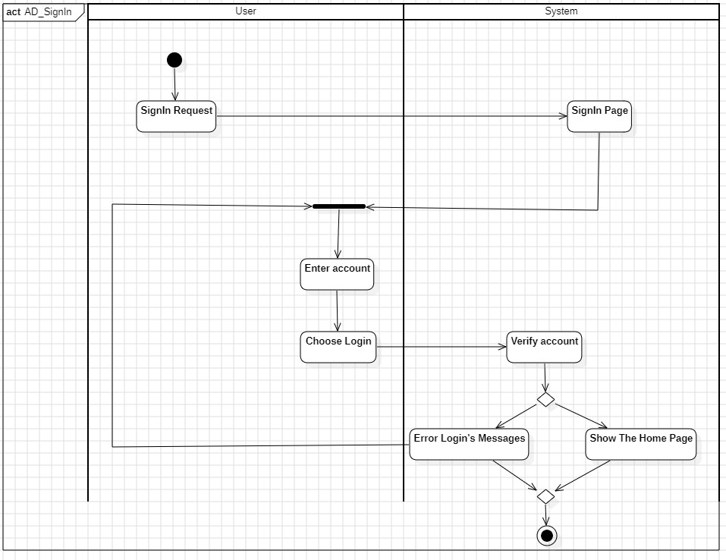

**2.2 Register**

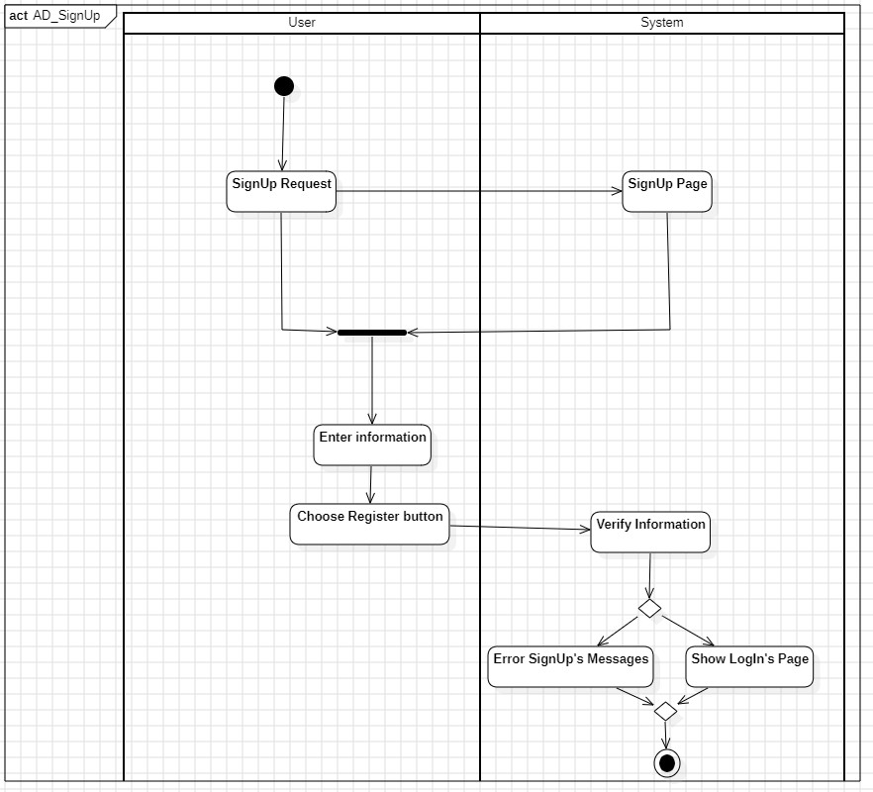

**2.3 View menu**

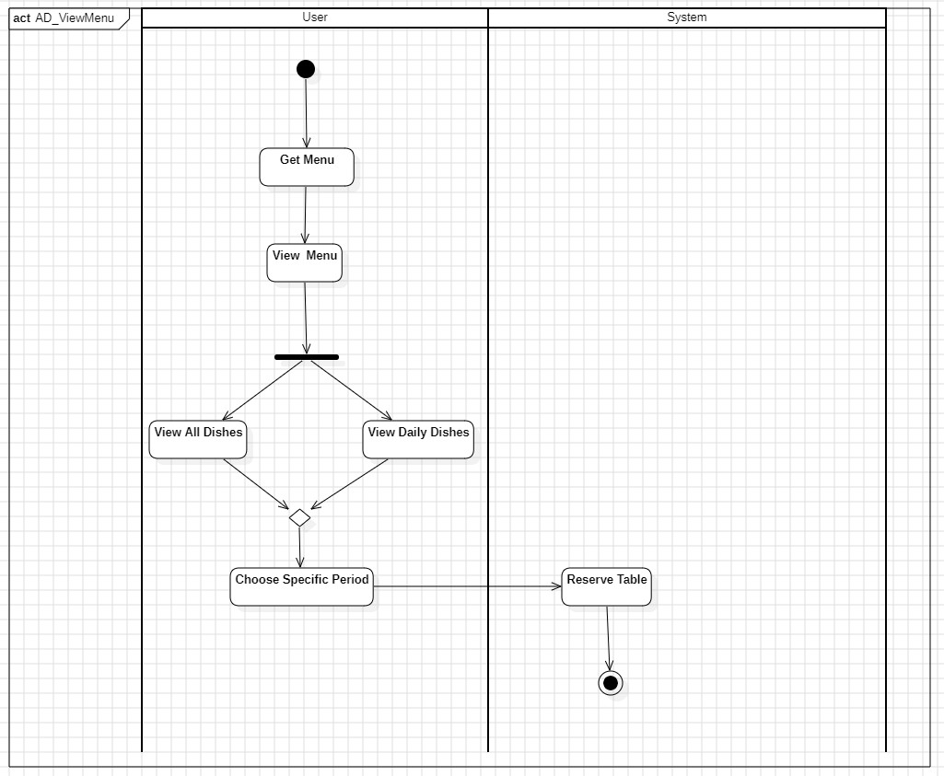

**2.4 Reserve Table**

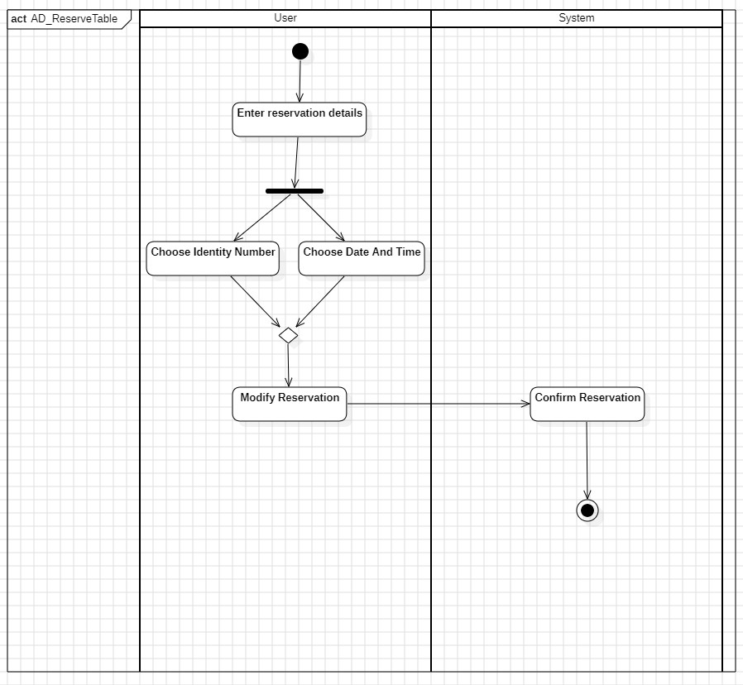

**2.5 Place order**

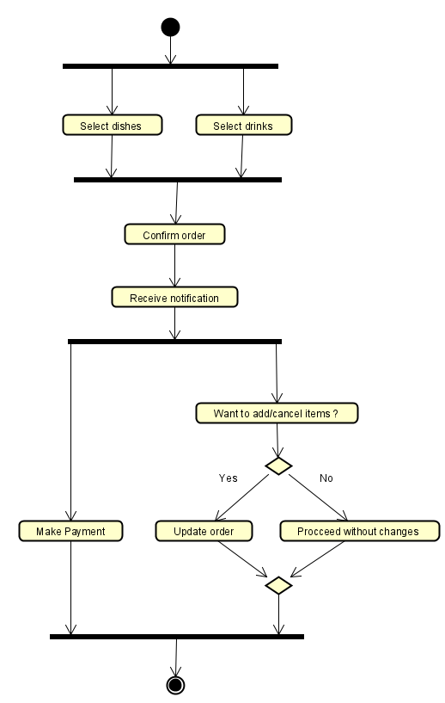

**2.6 Make Payment**

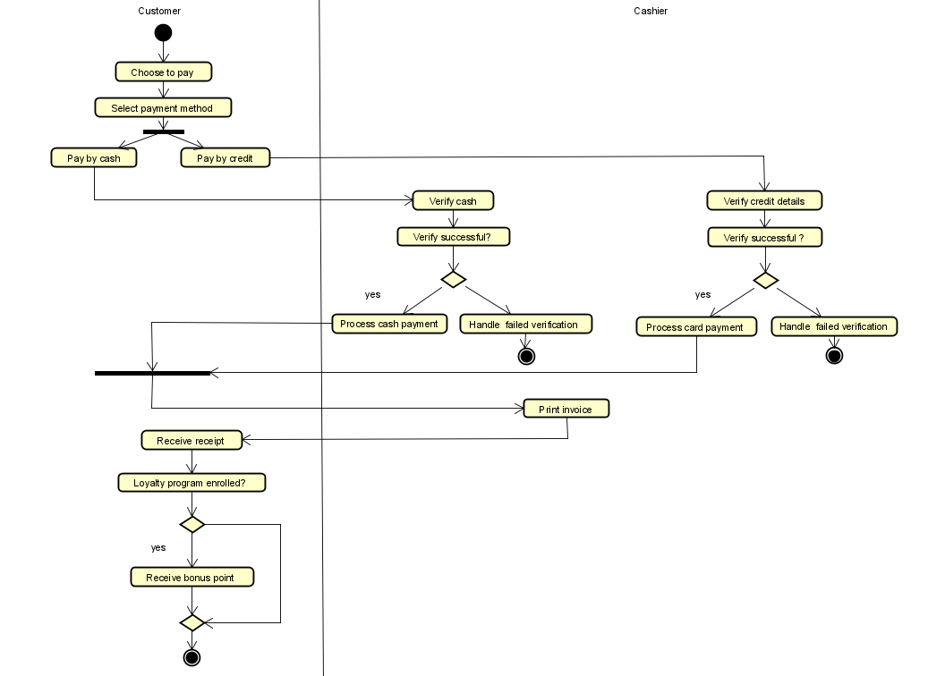

**2.7 Manage daily dishes**

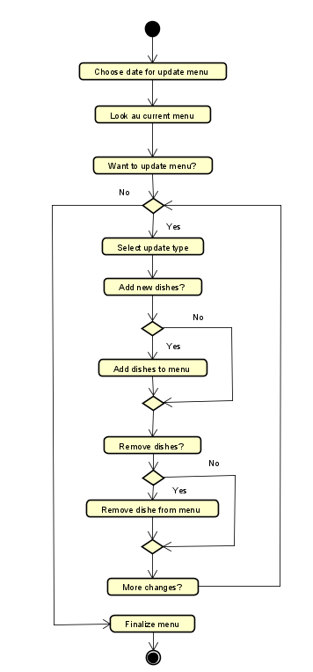

**2.8 View orders**

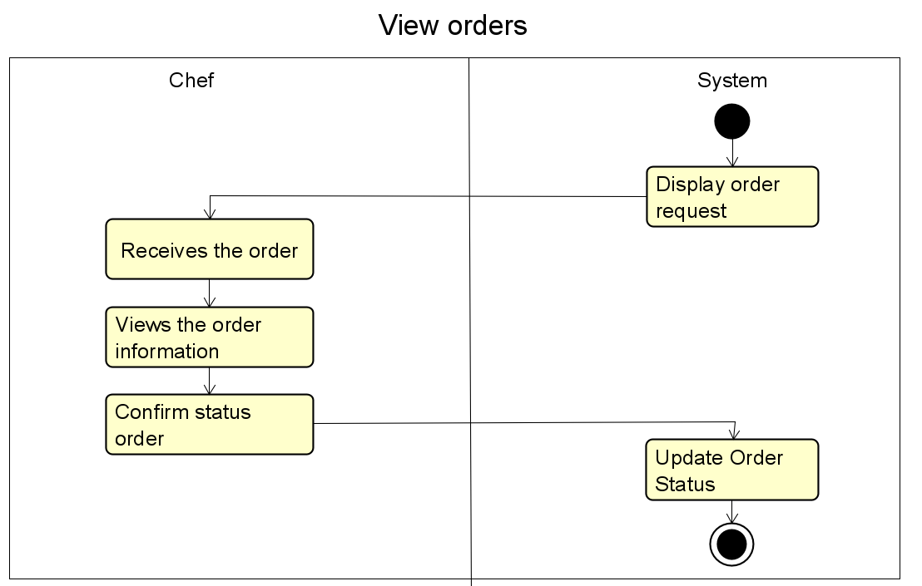

**2.9 Manage reservations**

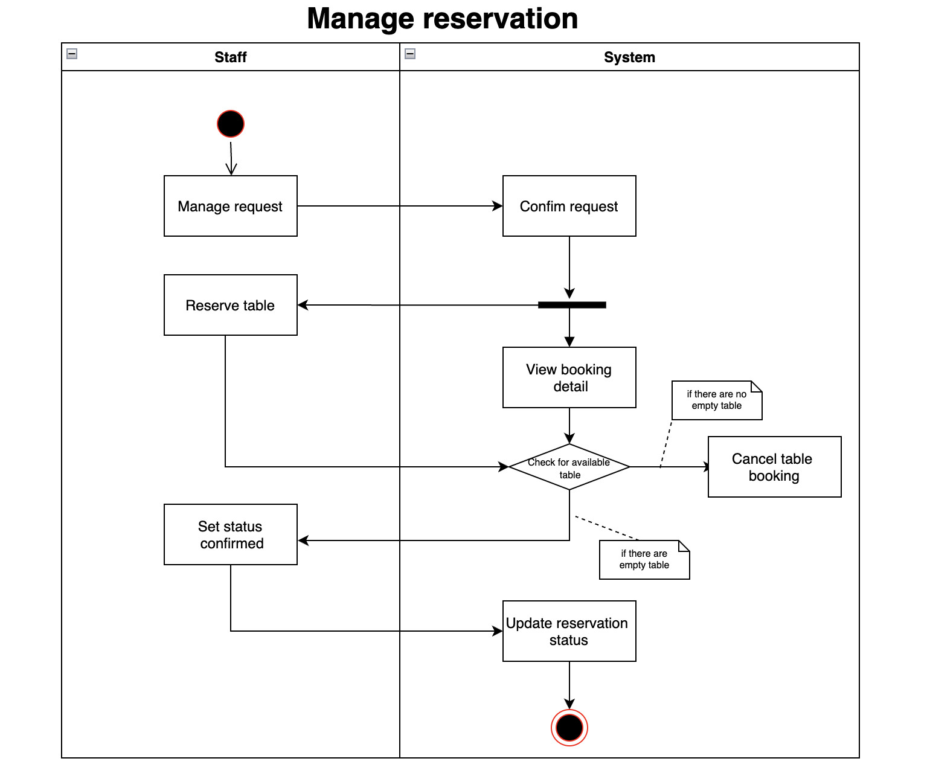

**2.10 View sales**

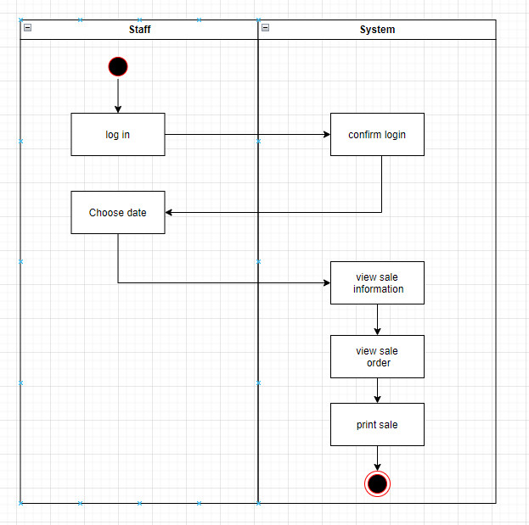

**Task 3/ Class diagram**

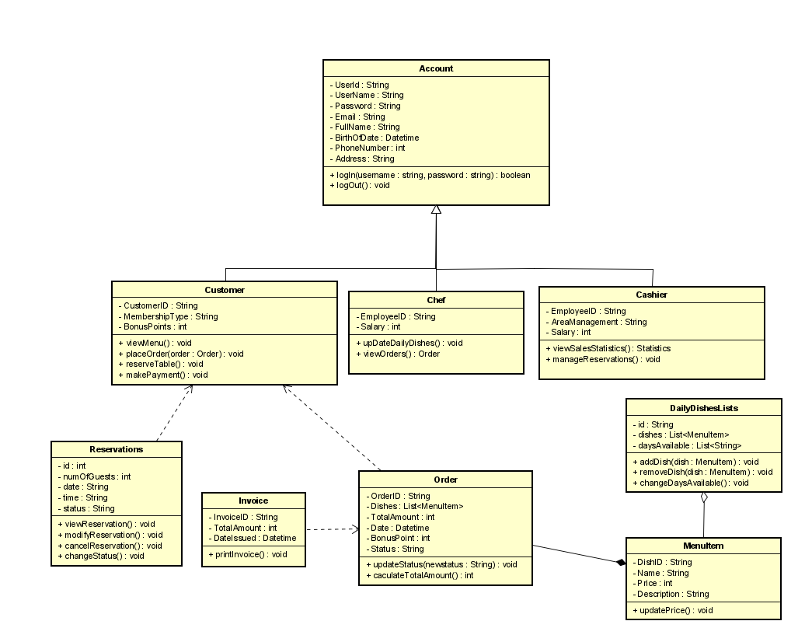

**Task 4/ Sequence diagram**

**4.1 Login**

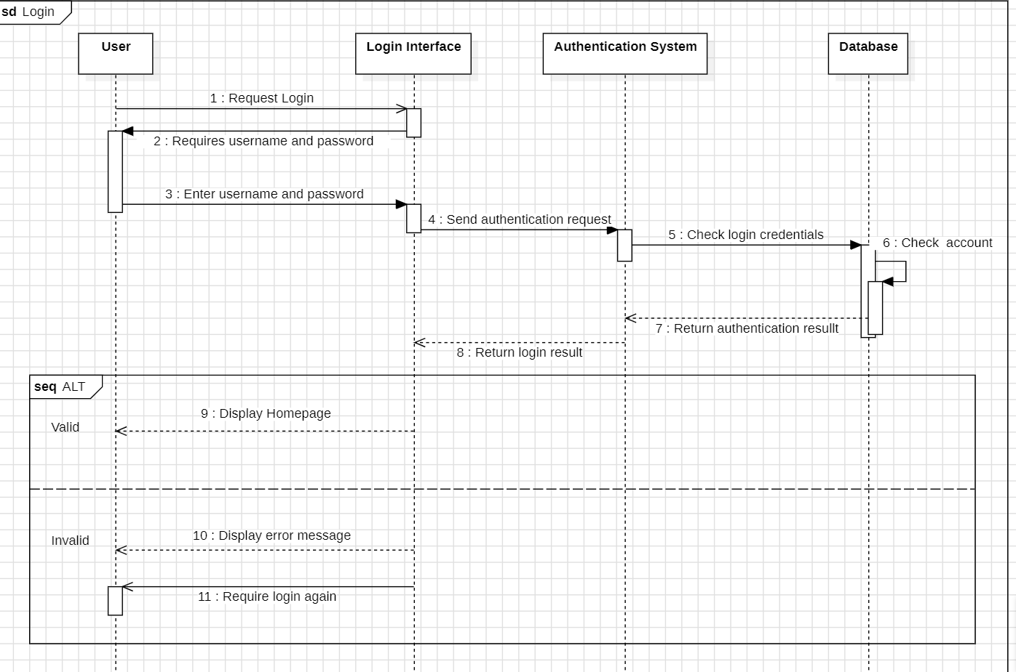

**4.2 Register**

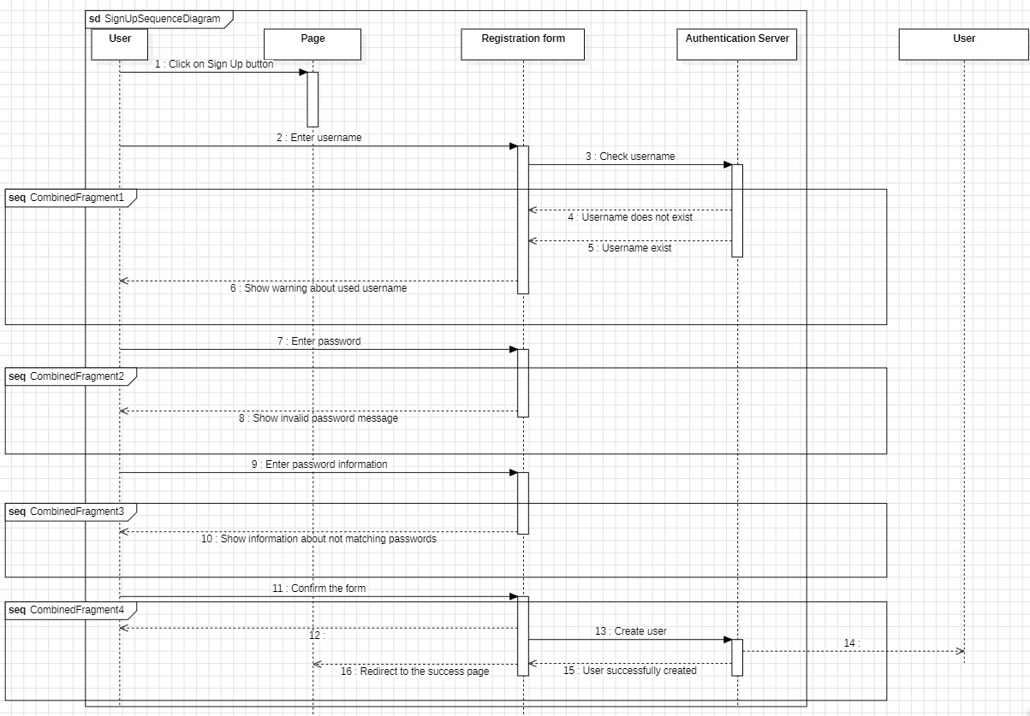

**4.3 View menu**

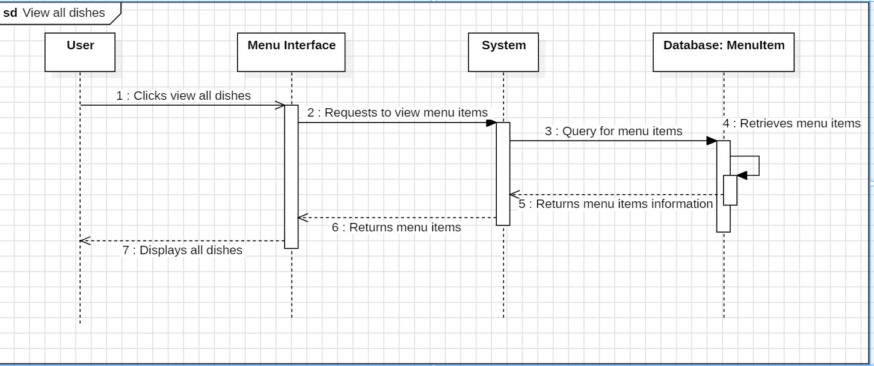

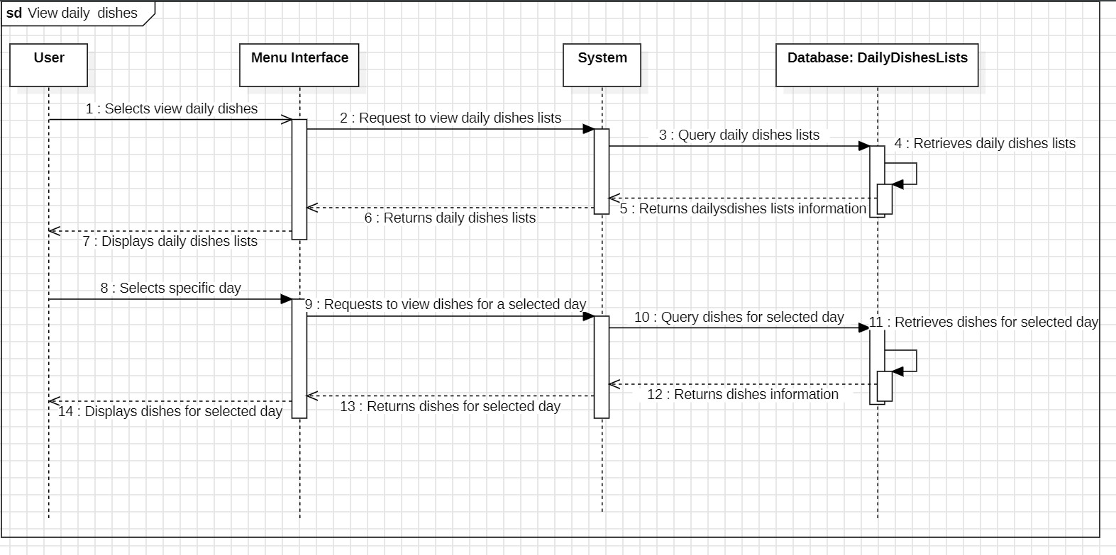

**4.4 Reserve Table**

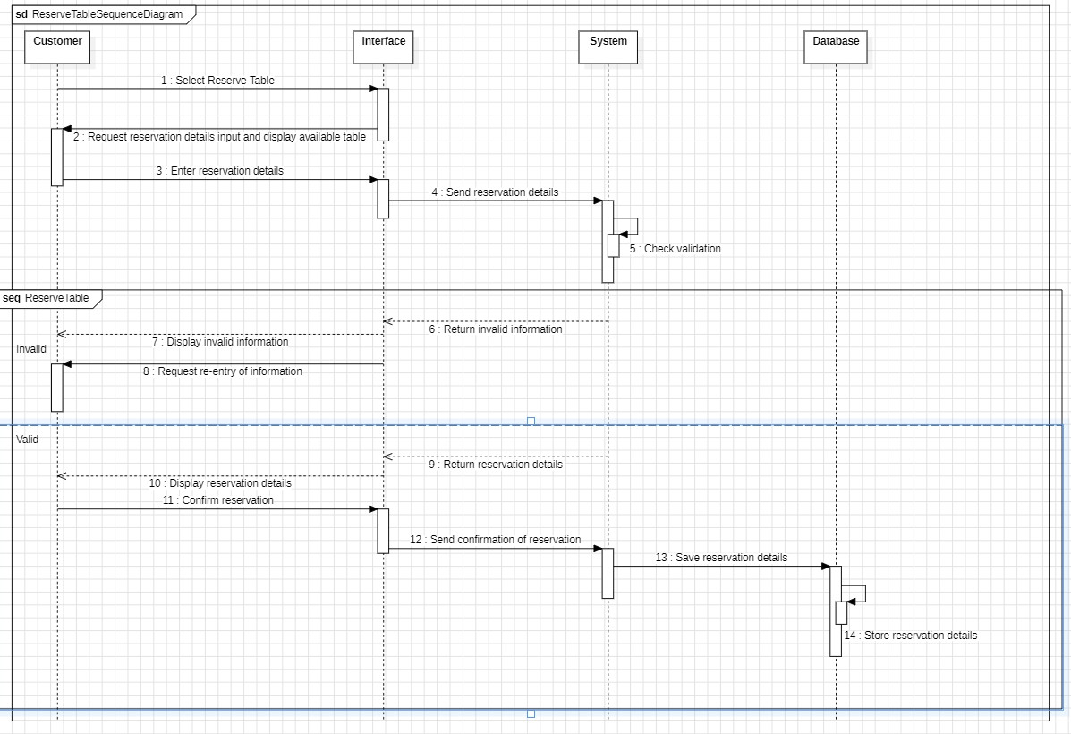

**4.5 Place order**

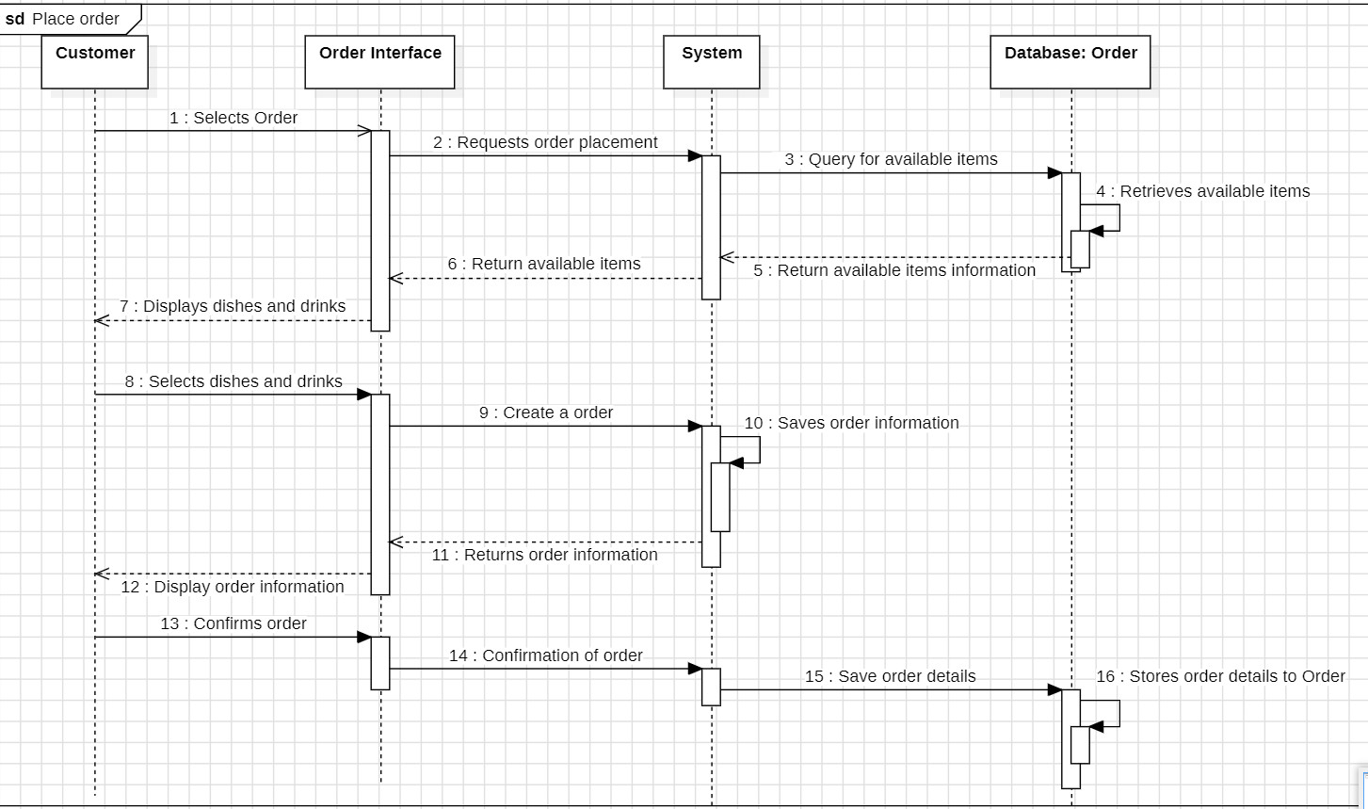

**4.6 Make Payment**

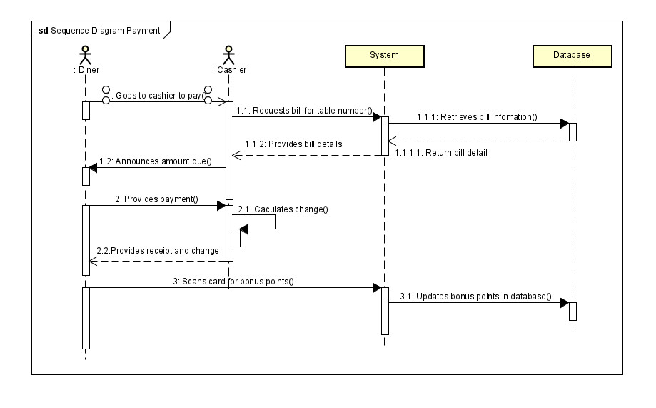

**4.7 Manage daily dishes**

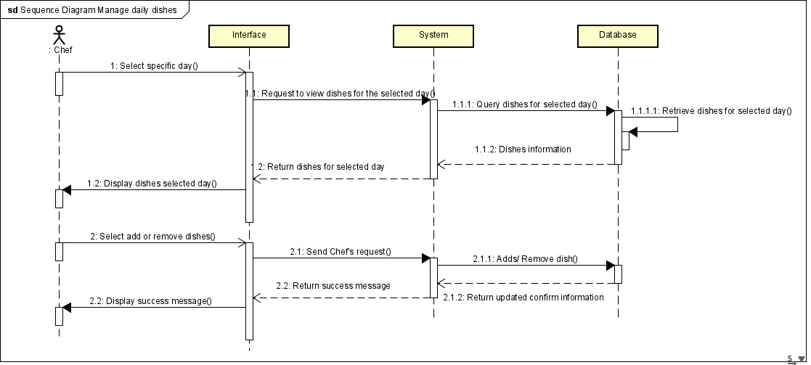

**4.8 View orders**

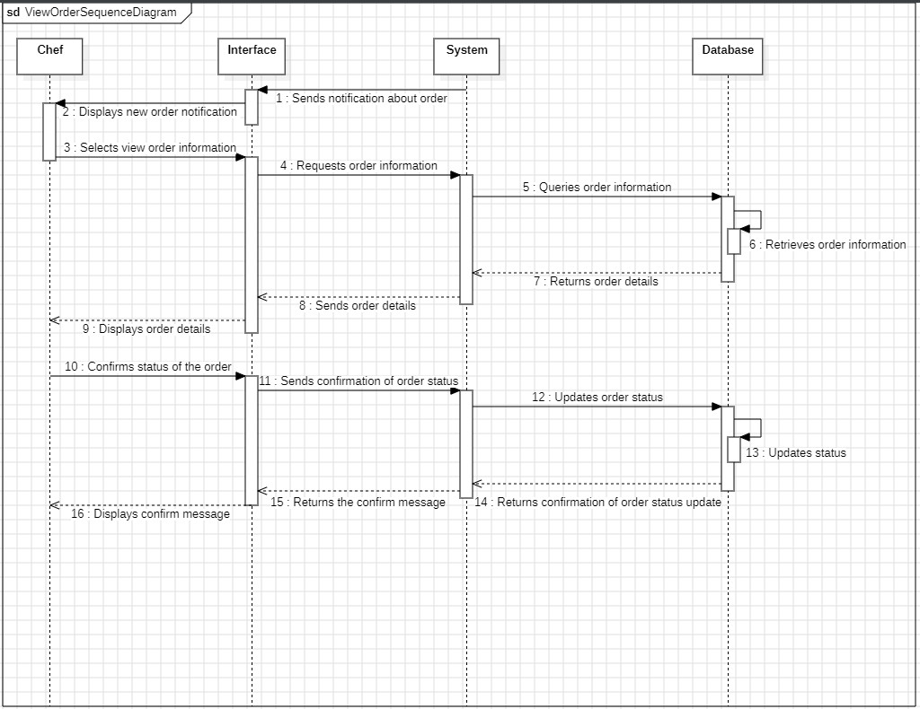

**4.9 Manage reservations**

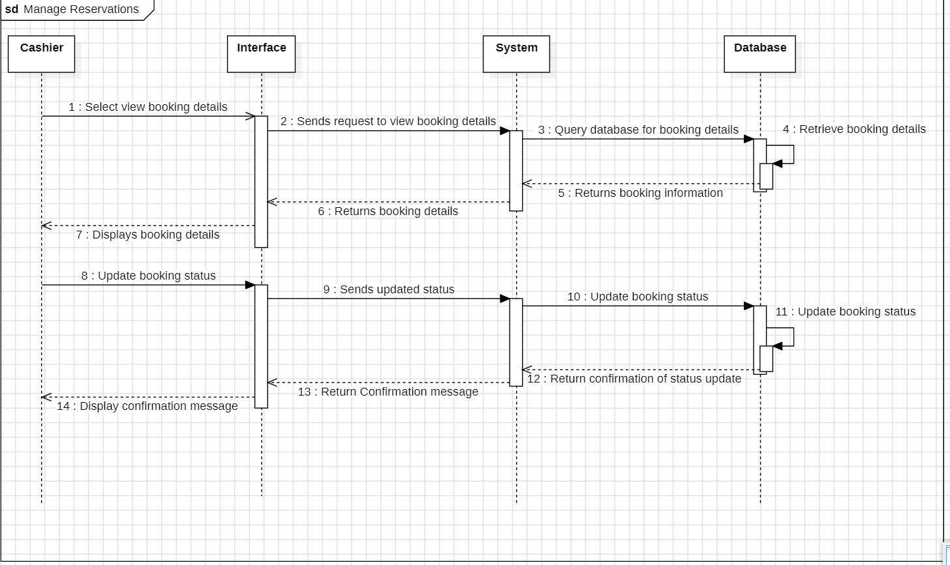

**4.10 View sales**

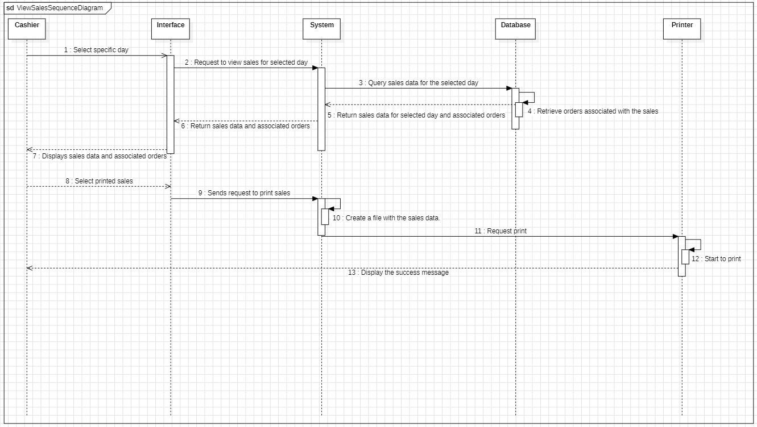

**Task 5: Database Model**